##### https://media.contentapi.ea.com/content/dam/eacom/en-gb/common/bejeweled-stars-logo.png

## ***MORE STRATEGY & CHALLENGES***

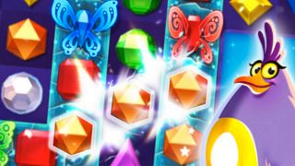

##### ***ABOUT:***

In Bejeweled Stars, the game board comes to life – and you can often decide when and how. Master Currents as they move strings of gems. Lift up gem-filled Clouds and drop them into different sections of the board to create explosive cascades. Rescue floating butterflies before they escape into the sky. It’s a brand-new matching experience that takes you far away from the everyday.